**Engagement Analysis**

**Average Total engagement by Content Type**

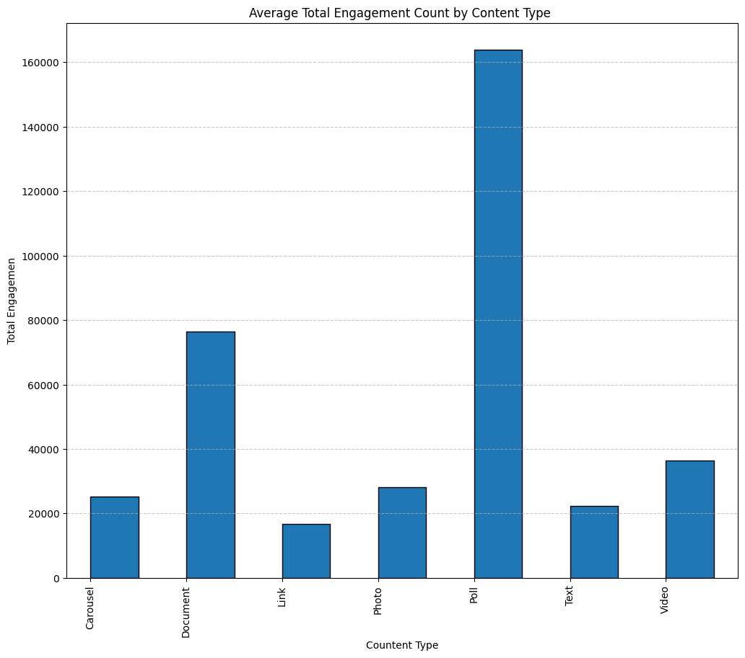

Poll content emerges as the most engaging type, boasting an engagement count twice as high as the second most engaging type, Document content.

Document content claims the second spot in terms of engagement, with a count twice as high as Video content, which secures the third position.

Video content follows as the third most engaging type, with an engagement count approximately 1.1 times as high as Photo content, which holds the fourth position.

Photo content ranks fourth in engagement, with a count about 1.2 times as high as Carousel content, placing fifth.

Carousel content takes the fifth position, with an engagement count around 1.1 times as high as Text content, which is the sixth most engaging type.

Text content follows as the sixth most engaging, with an engagement count approximately 1.2 times as high as Link content, the least engaging type.

Link content falls at the bottom, being the least engaging type, with an engagement count about 1.2 times as low as Carousel content, the fifth most engaging type.

In summary, polls stand out as the most engaging content, fostering participation and interactive engagement. Documents, ranking second, attract engagement with in-depth information and valuable resources. The appeal of visual and auditory elements makes videos a popular and engaging format, securing the third position. Carousels, with their diverse content, entice user interaction, placing fifth. However, purely text-based content, ranking sixth, may be less engaging due to its limited visual appeal. Notably, links, the least engaging, can reduce on-platform engagement as they lead users away.

These trends underscore that content types with interactivity and visual appeal tend to garner more engagement.

**Network Engagement**

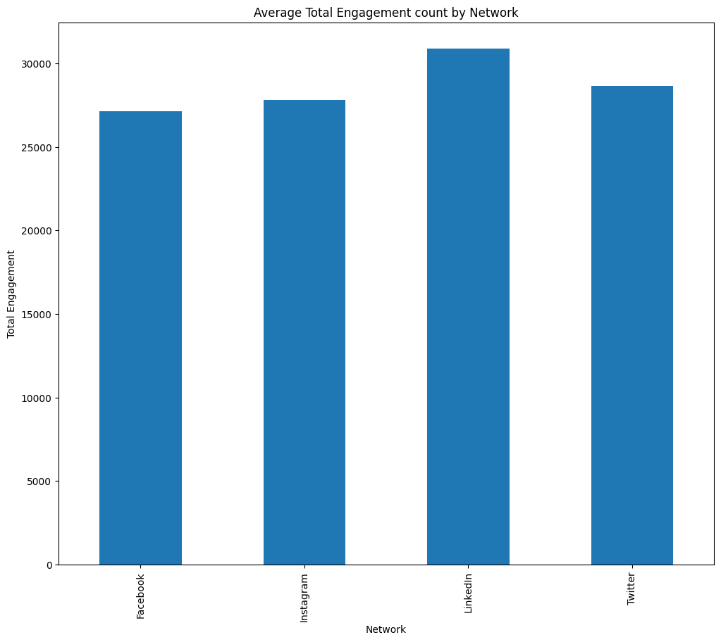

* **LinkedIn**: Highest network engagement, approximately 1.07 times as high as the second network, Twitter.
* **Twitter**: Second-highest network engagement, about 1.02 times as high as the third network, Instagram.
* **Instagram**: Third-highest network engagement, approximately 1.02 times as high as the fourth network, Facebook.
* **Facebook**: Least network engagement, roughly 1.02 times as low as the third network, Instagram.

LinkedIn outperforms other platforms, such as Twitter, Instagram, and Facebook, in terms of engagement. This could be due to its professional-focused audience, content relevance, active user engagement, and effective content recommendation algorithms. Users on LinkedIn, seeking professional connections and industry-specific content, may find the platform's polls and documents particularly engaging. The platform's dynamic and interactive environment, along with personalized content delivery, contributes to higher engagement rates. Conversely, while Twitter, Instagram, and Facebook have significant user bases, their content nature and user behavior might differ, affecting overall engagement. It's essential to recognize that these observations are generalizations, and specific engagement patterns may vary based on content strategy, audience demographics, and platform dynamics.

**Days Engagement**

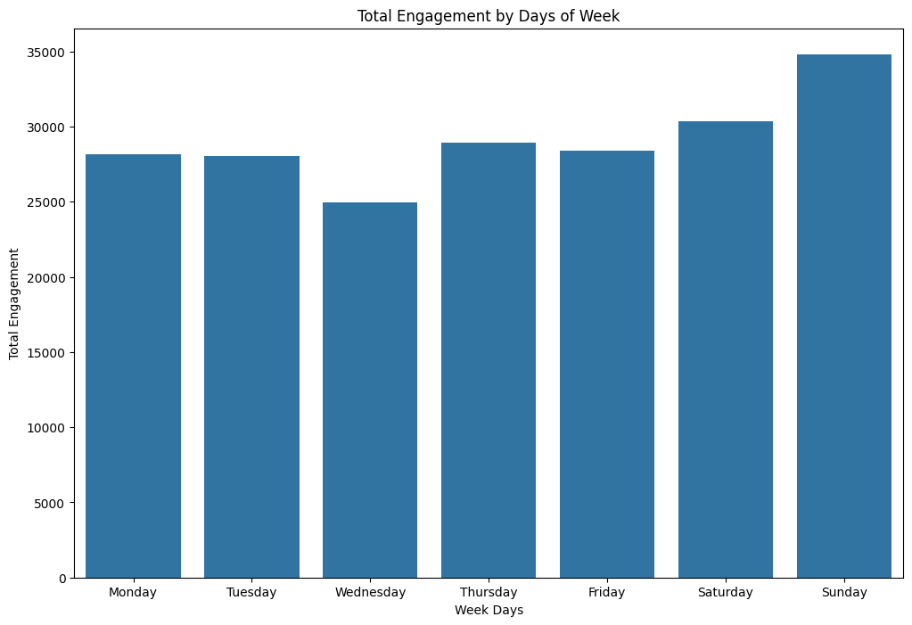

* **Sunday:** Has the highest total engagement among the days of the week, about 1.1 times as high as the second-highest engagement day, Saturday.
* **Saturday:** Is the second-highest total engagement day, about 1.04 times as high as the third-highest engagement day, Thursday.
* **Thursday:** Is the third-highest total engagement day, about 1.03 times as high as the fourth-highest engagement day, Friday.
* **Friday:** Is the fourth-highest total engagement day, about 1 time as high as the fifth-highest engagement day, Monday.
* **Monday:** Is the fifth-highest total engagement day, about 1 time as high as the sixth-highest engagement day, Tuesday.
* **Tuesday:** Is the sixth-highest total engagement day, about 1.1 times as high as the seventh-highest engagement day, Wednesday.
* **Wednesday:** Has the least total engagement among the days of the week, about 1.1 times as low as the sixth-highest engagement day, Tuesday.

The variations in total engagement across the days of the week could be influenced by several factors. Sundays might witness higher engagement due to increased leisure time, as people are often more relaxed and active on weekends. Additionally, Sunday evenings may be a popular time for social media use as individuals prepare for the upcoming week. Saturdays being the second-highest engagement day could be attributed to a similar weekend effect. Thursdays, as the third-highest engagement day, might experience increased activity as people engage with content before the weekend. Fridays, while still active, could see a slight dip in engagement as individuals may be occupied with end-of-week responsibilities. Mondays, being the start of the workweek, might experience higher engagement as people catch up on updates after the weekend. Tuesdays, the sixth-highest engagement day, could see increased activity, possibly due to ongoing work discussions and content catch-up. Wednesdays, having the least engagement, might be influenced by the midweek slump when people are focused on work and have less time for social media. These insights suggest a complex interplay of factors, including leisure time, work schedules, and content preferences, contributing to the observed patterns in network engagement across the days of the week.

**Hourly Engagement**

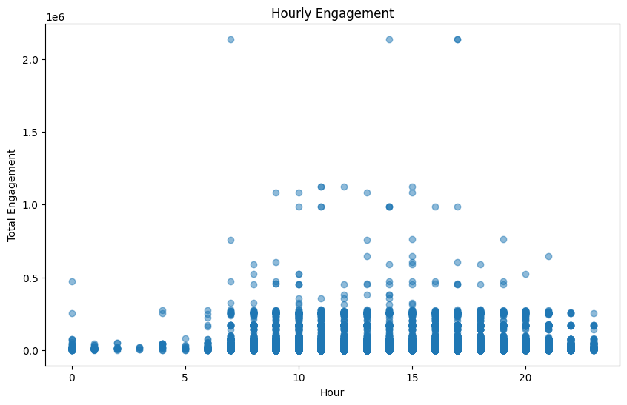

* People tend to engage more on social media at 7 AM, 2 PM, and 5 PM, with these hours sharing the same high engagement rate.

People tend to engage more on social media at 7 AM, 2 PM, and 5 PM, likely due to common daily routines. The morning hours align with the start of the day, 2 PM corresponds to a common break period, and 5 PM marks the end of the workday. These hours share a consistently high engagement rate, possibly reflecting established user habits or accommodating a global audience across different time zones.

**Engagement Variation Across Social Media Platforms Throughout the Week.**

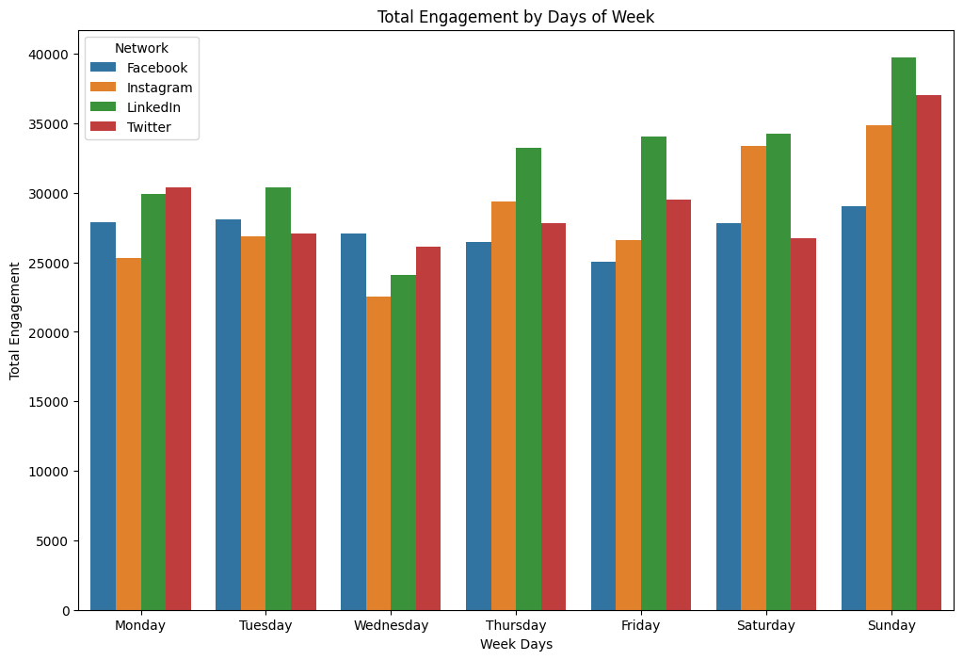

* On Monday, more people engaged on Twitter, followed by LinkedIn, Facebook, and Instagram.
* On Tuesday, more people engaged on LinkedIn, followed by Facebook, with Instagram and Twitter almost the same.
* On Wednesday, more people engaged on Facebook, followed by Twitter, LinkedIn, and Instagram.
* On Thursday, more people engaged on LinkedIn, followed by Instagram, Twitter, and Facebook.
* On Friday, more people engaged on LinkedIn, followed by Twitter, Instagram, and Facebook.
* On Saturday, more people engaged on LinkedIn, followed by Instagram, Facebook, and Twitter.
* On Sunday, more people engaged on LinkedIn, followed by Twitter, Instagram, and Facebook.

Throughout the week, different social media platforms experience varying engagement patterns. On Mondays, Twitter tends to witness heightened engagement as users catch up on news post-weekend, followed by LinkedIn, where professionals engage with work-related content. Facebook and Instagram then come into play as users transition to more casual, social content. On Tuesdays, LinkedIn sees increased engagement due to its professional networking focus, while Facebook and Instagram attract users seeking a mix of personal and professional content. Twitter's engagement remains steady but slightly lower, influenced by the professional emphasis on LinkedIn. Midweek, Wednesday sees heightened engagement on Facebook as users seek a break, with increased activity on Twitter as well. LinkedIn maintains its professional focus, while Instagram attracts moderate engagement with its visual content. Thursdays witness sustained high engagement on LinkedIn, particularly for professional networking, and increased activity on Instagram as users look forward to the weekend. Twitter and Facebook follow with mixed engagement. As the workweek concludes on Fridays, professional engagement on LinkedIn decreases, leading to a spike in Twitter engagement as users share thoughts on the week. Instagram and Facebook continue to see engagement as users unwind and share casual content. On Saturdays, LinkedIn's engagement drops further as the weekend kicks in. Instagram, with its visual appeal, experiences higher engagement, while Facebook and Twitter observe mixed engagement as users balance personal and social interactions. These patterns offer insights into the dynamics of platform usage throughout the week, reflecting the varying preferences and behaviors of social media users.

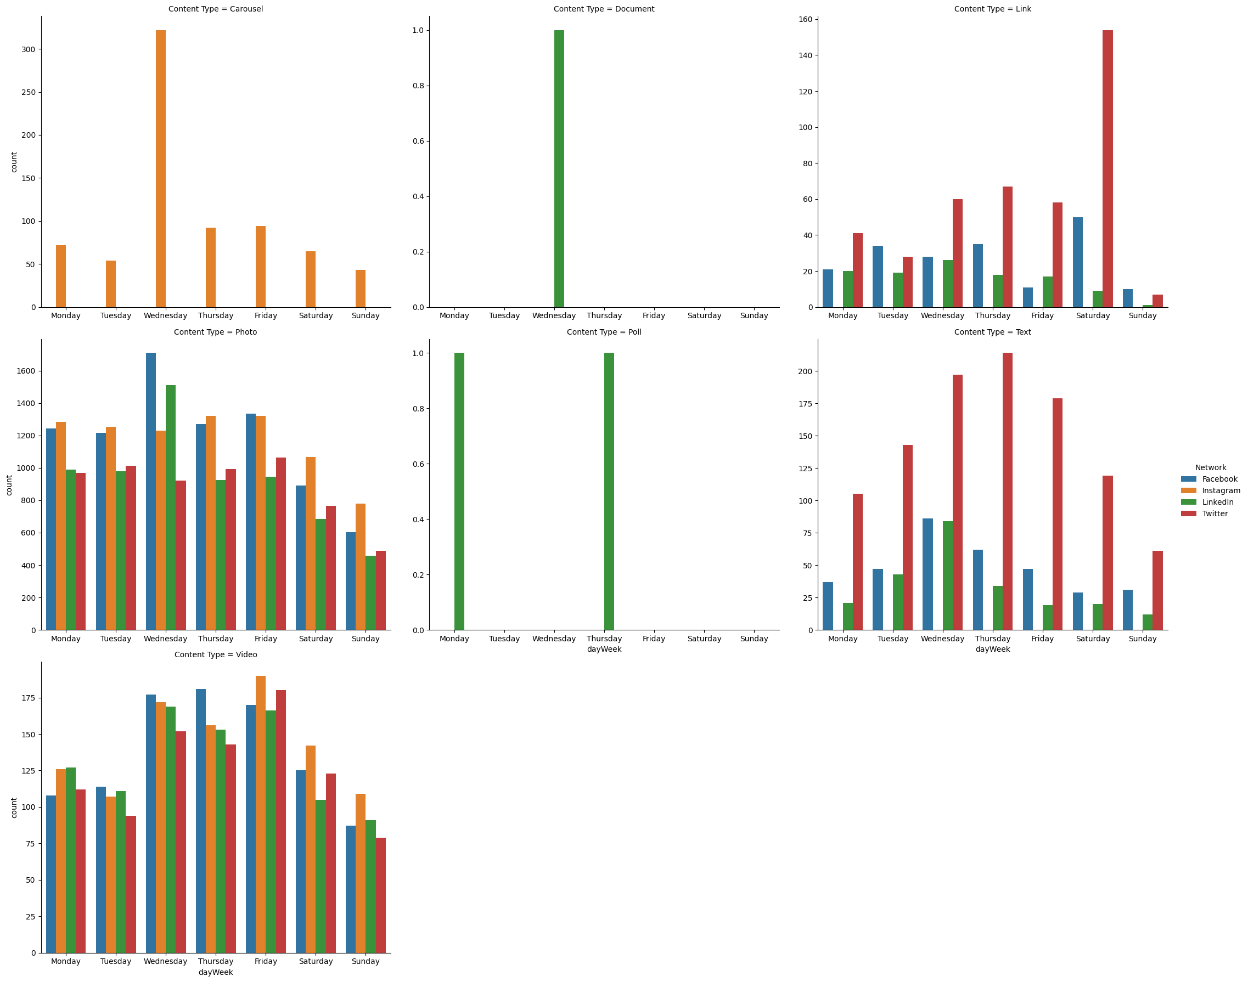

**Content Type Analysis:**

Carousel: Carousel content is exclusively engaged on Instagram, with the highest engagement observed on Wednesday, three times as high as the second-highest day, Friday. Thursday, the third-highest engagement day, is nearly as high as Friday. Monday and Saturday share similar engagement levels, ranking fourth and fifth, respectively. Tuesday is the sixth-highest engagement day, approximately one times as high as the least engaged day, Sunday.

Document: Document content only receives engagement on LinkedIn, specifically on Wednesdays.

Link: Link content sees the highest engagement on Twitter on Mondays, twice as high as the second most engaged network, Facebook. Instagram has zero engagement throughout the week on link content. On Tuesdays, Facebook leads in engagement on link content, approximately 1.1 times as high as Twitter. On Wednesdays, Twitter dominates with engagement, twice as high as Facebook, while Facebook and LinkedIn are almost equal. Thursdays see Twitter leading again, twice as high as Facebook, which is twice as high as LinkedIn. Fridays witness Twitter with the highest engagement, three times as high as LinkedIn. Saturdays and Sundays maintain low engagement, with Facebook leading on Sundays.

Photo: Monday sees the highest engagement based on photo content, slightly higher than Facebook, with LinkedIn and Twitter following. Tuesdays show Instagram leading, slightly higher than Facebook, while being 1.2 times higher than Twitter and LinkedIn. Wednesdays see Facebook leading, approximately 1.2 times higher than LinkedIn, which is 1.25 times higher than Instagram and 1.3 times higher than Twitter. Thursdays have Instagram leading, equal to the second, Facebook, which is 1.3 times higher than the third, Twitter. Fridays have Facebook leading slightly higher than Instagram, with both being 1.3 times higher than Twitter, the third. Saturdays and Sundays follow the same trend.

Poll: Poll content engages exclusively on LinkedIn, appearing on Monday and Thursday.

Text: Twitter dominates text content engagement on Mondays, three times as high as Facebook, which is 1.5 times higher than LinkedIn. Tuesdays see Twitter leading, three times as high as Facebook, which is 1 times as high as LinkedIn. Wednesdays witness Twitter leading again, 2.5 times as high as Facebook, with Facebook slightly higher than LinkedIn. Thursdays have Twitter with the highest engagement, 3.5 times as high as Facebook, which is 2 times as high as LinkedIn. Fridays see Twitter leading, four times as high as Facebook, which is 2 times as high as LinkedIn. Saturdays and Sundays continue the trend, with Twitter leading.

Video: Mondays show LinkedIn leading in video content engagement, closely followed by Instagram. Tuesdays see Facebook in the lead, a little higher than LinkedIn, while LinkedIn is slightly higher than Instagram, with Instagram being 1.5 times higher than Twitter. Wednesdays have Facebook leading, slightly higher than Instagram, with Instagram being slightly higher than LinkedIn, and LinkedIn being 1.3 times higher than Twitter. Thursdays witness Facebook leading, 1.3 times higher than Instagram, which is 1 times higher than LinkedIn, with LinkedIn being 1.2 times higher than Twitter. Fridays have Instagram in the lead, 1.2 times higher than Twitter, which is 1.2 times higher than Facebook, and Facebook being 1 times higher than LinkedIn. Saturdays follow the same trend as Fridays, and Sundays follow the same trend as Thursdays.

These insights may be attributed to the distinctive characteristics of each social media platform, catering to unique user preferences and engagement behaviors. The observed variations can be influenced by the nature of content each platform supports, the demographics of their user base, and the platform's design and features. For example, the exclusive engagement of Carousel content on Instagram may be a result of the platform's visually-focused nature, with users finding interactive and dynamic carousels particularly appealing. Similarly, the dominance of LinkedIn for Document content could be linked to the professional and business-oriented audience on the platform. The engagement patterns for different content types on specific days further suggest that user behavior and preferences fluctuate throughout the week, emphasizing the importance of strategic content planning and scheduling tailored to each platform's dynamics and user base.

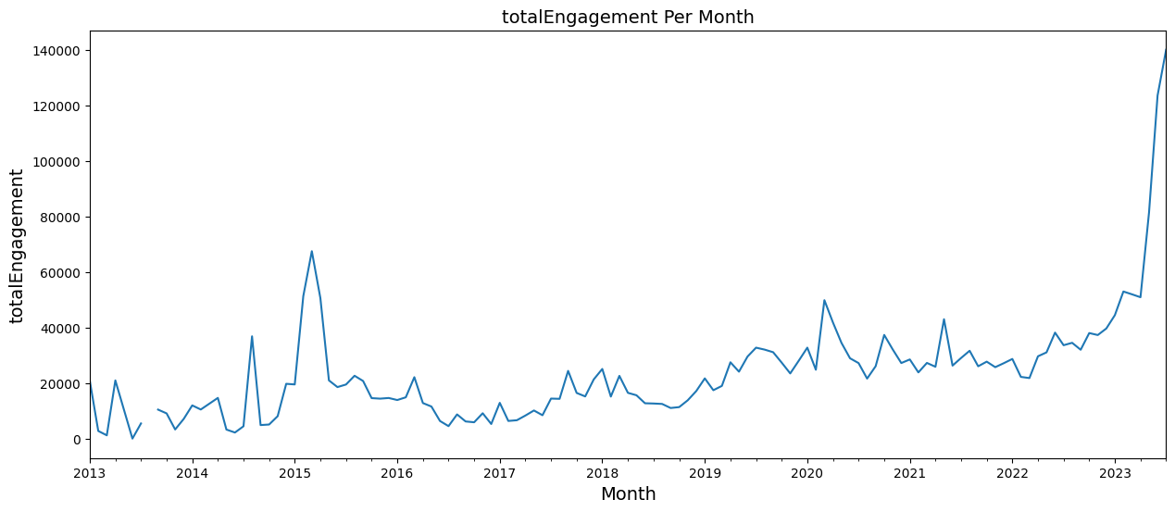

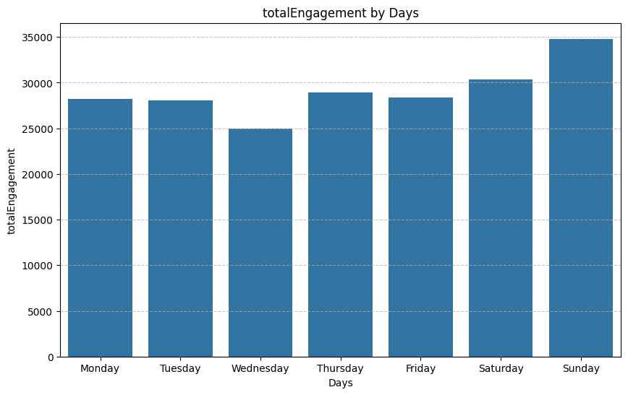

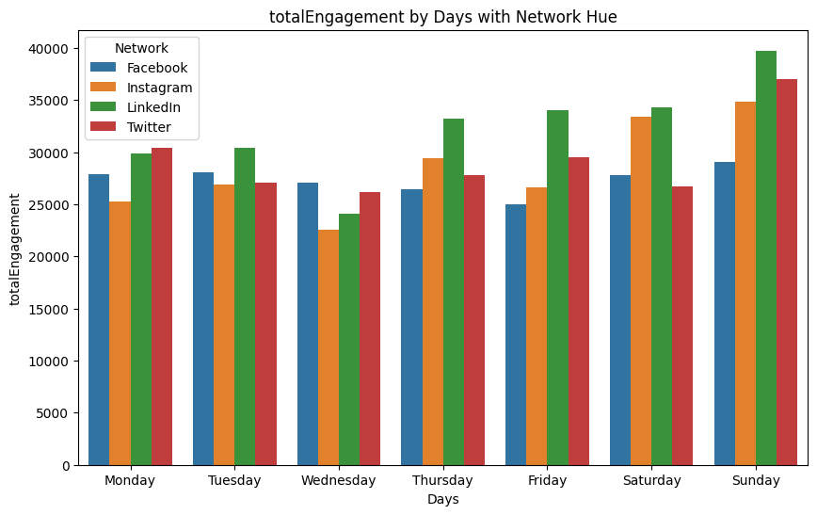

**Engagement Analysis**



There is a persistent pattern of rising and falling total engagement throughout the year, with the highest peak occurring in the second quarter of 2023, reaching approximately 140,000 total engagements. The second peak is in the first quarter of 2015, totaling about 70,000 engagements, which is 2 times lower than the highest peak. The third peak is in the first quarter of 2020, with about 50,000 total engagements, approximately 1.4 times lower than the third-highest peak.



In terms of weekly engagement, Sunday leads with the highest total engagement count, reaching 34,000. Saturday follows as the second most engaged day with about 30,000 counts, while Thursday secures the third position with around 29,000 counts. Friday claims the fourth position with about 28,000 counts, and Monday and Tuesday share the same total engagement of approximately 27,500 counts. Wednesday has the least engagement with a count of 25,000.



On a daily basis, Twitter dominates engagement on Monday with the highest count of 30,000, followed by LinkedIn with around 29,000 total engagements. Facebook ranks third with 27,000 engagements, and Instagram has the lowest count at 25,000. Tuesday sees LinkedIn leading with 30,000 total engagements, while Facebook follows with around 28,000 counts, and Instagram and Twitter share the same count of about 27,000.

Wednesday sees Facebook taking the lead with around 27,000 total engagements, followed by Twitter with about 26,000. LinkedIn secures the third position with 24,000 total engagements, and Instagram trails with the least count of 22,500. Thursday witnesses LinkedIn again leading with around 32,000 total engagements, followed by Instagram with 28,000 counts. Twitter, in the third position, has 27,000 total engagements, and Facebook trails with 26,000.

On Friday, LinkedIn maintains its lead with about 33,000 total engagements, followed by Twitter with 28,000 counts. Instagram, in the third position, has 26,000 total engagements. Saturday sees LinkedIn leading again with around 33,000 counts, followed closely by Instagram with 32,000. Facebook secures the third position with 26,500, and Twitter trails with 25,000.

Sunday witnesses LinkedIn with the highest total engagement count of about 39,000, followed by Twitter with approximately 37,000 counts. Instagram secures the third position with a total engagement count of 34,000, while Facebook lags behind with 29,000 total engagements.

The fluctuation in total engagement throughout the year suggests a dynamic pattern influenced by various factors. The peaks in the second quarter of 2023 and the first quarter of 2015 could be linked to specific events or content strategies that resonated exceptionally well with the audience during those periods. The weekly engagement analysis reveals that Sunday consistently leads, potentially indicating that users are more active and engaged on this day. On a daily basis, Twitter's dominance on Monday and LinkedIn's lead on Tuesday and Thursday may be reflective of specific content strategies aligned with user behavior patterns on these platforms. The variations across days and platforms emphasize the importance of strategic content planning tailored to specific timeframes and platforms to maximize engagement.

**Click Through Rate Analysis**

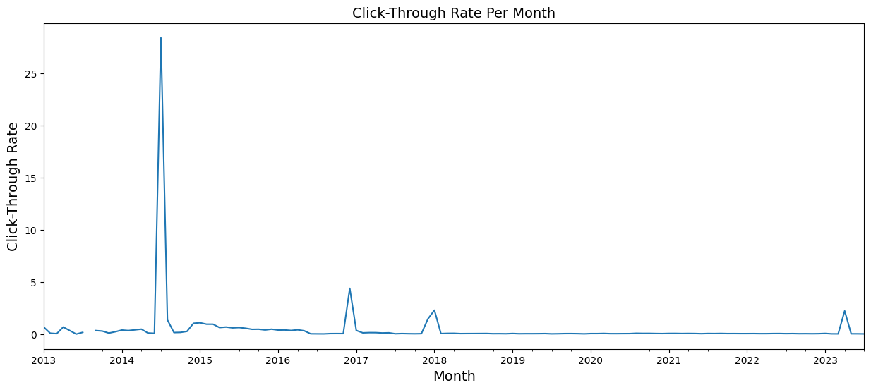

From 2013 to the first quarter of 2014, there is a fluctuation in the click-through rate (CTR) within 1%. The highest peak occurs in the second quarter of 2014, exceeding 25%, which can be considered exceptionally high. The second-highest peak is observed in the last quarter of 2016, reaching about 4%. From the first quarter of 2018 to the first quarter of 2023, there is a consistent CTR of approximately 1%.

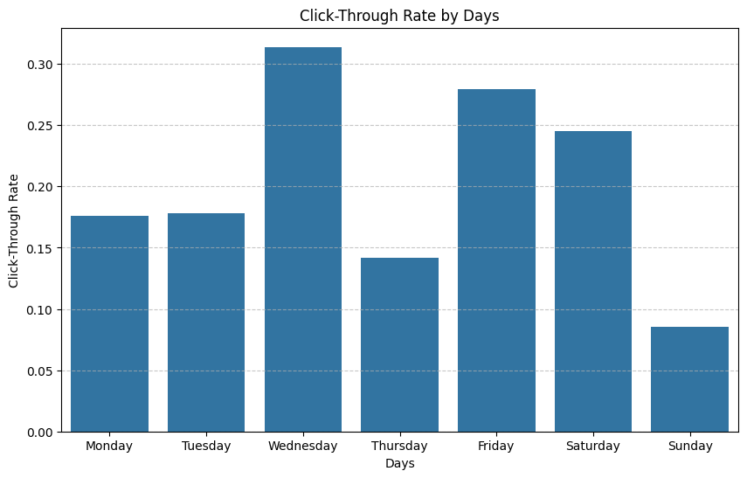

Breaking down the CTR by days of the week, Wednesday sees the highest CTR, surpassing 0.30%. Friday follows with the second-highest CTR around 0.27%, and Saturday holds the third position with a CTR of approximately 0.24%. Tuesday and Monday share the same CTR at around 0.175%. Thursday has the sixth-highest CTR at about 0.14%, and Sunday has the lowest CTR at approximately 0.07%.

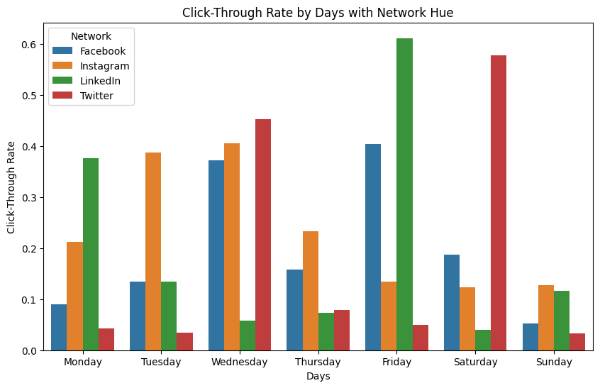

Analyzing CTR on specific platforms, on Monday, LinkedIn boasts the highest CTR at about 0.37%, followed by Instagram with the second-highest CTR of about 0.21%. Facebook comes in third with a CTR of approximately 0.08%, and Twitter has the lowest CTR at around 0.05%.

On Tuesday, Instagram takes the lead with the highest CTR of about 0.38%. Facebook and LinkedIn share the same CTR of about 0.13%, while Twitter maintains the lowest CTR at 0.05%.

Moving to Wednesday, Twitter claims the highest CTR at about 0.45%, followed closely by Instagram with a CTR of 0.4%. Facebook secures the third-highest CTR at approximately 0.38%, and LinkedIn has the lowest CTR at about 0.05%.

Thursday sees Instagram with the highest CTR at about 0.22%, followed by Facebook at 0.15%. Twitter ranks third with a CTR of about 0.08%, and LinkedIn has the least with 0.07% CTR.

On Friday, LinkedIn dominates with the highest CTR at about 0.6%, followed by Facebook at 0.38%. Instagram takes the third position with a CTR of 0.14%, while Twitter has the lowest, below 0.05%.

Saturday sees Twitter with the highest CTR at about 0.57%, followed by Facebook at 0.18%. Instagram holds the third position with a CTR of 0.13%, and LinkedIn has the lowest CTR, below 0.05%.

Finally, on Sunday, Instagram leads with the highest CTR at about 0.12%, followed by LinkedIn at 0.11%. Facebook secures the third-highest CTR at about 0.05%, while Twitter has the lowest, below 0.05%.

The observed fluctuations and patterns in click-through rates (CTR) over the years and across days and platforms could be attributed to a combination of user behavior, platform dynamics, and content strategies. The substantial peak in the second quarter of 2014 may be linked to a specific campaign, event, or content format that resonated exceptionally well with the audience during that period. The consistent CTR from the first quarter of 2018 to the first quarter of 2023 suggests a level of stability or plateauing in user engagement during this timeframe. The variations in CTR across days of the week and platforms highlight the influence of specific user demographics, content preferences, and platform features on engagement. For instance, Wednesday consistently stands out with the highest CTR, indicating that users may be more receptive or active on this day. The platform-specific CTR variations on Monday, Tuesday, and Wednesday further underscore the impact of content relevance and user behavior on engagement metrics. Overall, these insights emphasize the importance of adapting content strategies based on nuanced user patterns and platform-specific dynamics to optimize click-through rates.

**Impression Analysis**

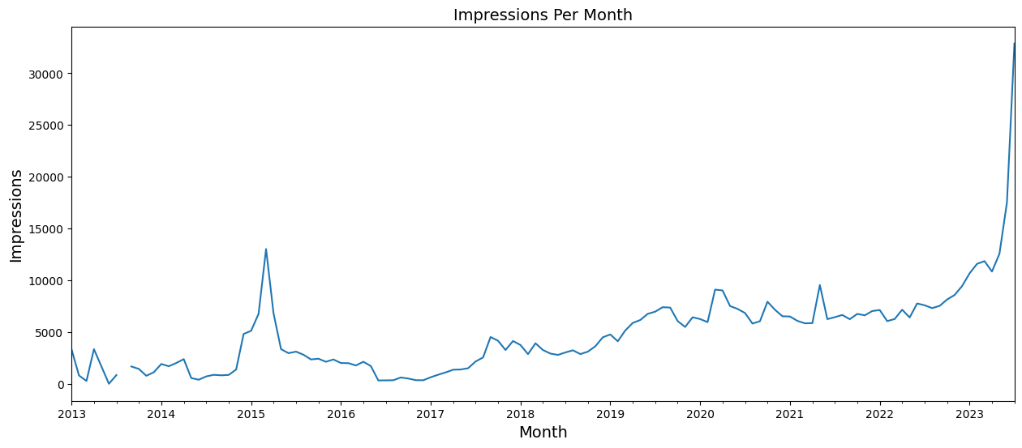

From 2013 to the third quarter of 2014, there is a fluctuation in impressions, staying below 5000. Following this, there is a steady increase, reaching a peak of about 14,000 impressions. The peak then gradually falls below 5000 in the first quarter of 2015, experiencing subsequent rises and falls until the highest peak in the second quarter of 2023. The second-highest peak occurs in the first quarter of 2015, reaching about 14,000, while the lowest peak happens in the first quarter of 2013.

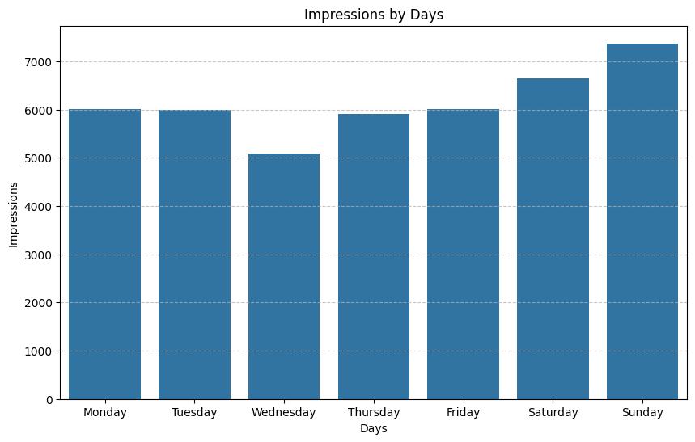Breaking down impressions by days of the week, Sunday has the highest impression, exceeding 7000, followed by Saturday with about 6,800. Friday, Monday, and Tuesday each have impressions of 6000. Thursday holds the fourth position with 5900 impressions, and Wednesday has the least, about 5100.

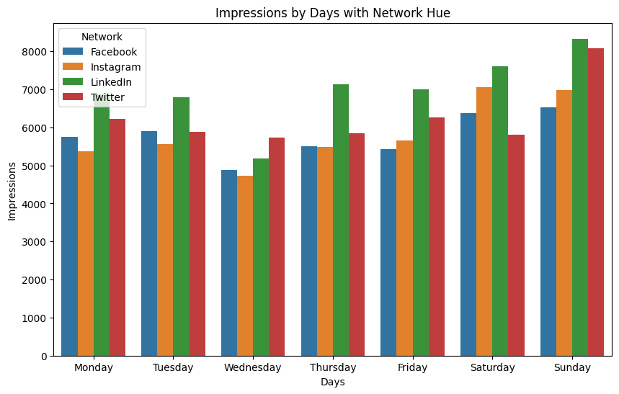

Examining platform-specific impressions on Mondays, LinkedIn takes the lead with the highest impression of about 6800, followed by Twitter with about 6200. Facebook comes third with approximately 5800 impressions, and Instagram has the least, about 5250.

On Tuesdays, LinkedIn claims the highest impression of about 6,800, while Facebook and Twitter share the same impression of 5,800. Instagram has the least impressions.

Wednesday sees Twitter with the highest impression of about 5600, followed by LinkedIn with about 5200 impressions. Facebook comes third with 4,800 impressions, and Instagram has the least, about 4,700.

Thursday witnesses LinkedIn with the highest impression of about 6,800, followed by Twitter with 5,900 impressions. Facebook and Twitter almost share the same impression, around 5,500.

On Fridays, LinkedIn leads with the highest impression of about 6,700, followed by Twitter with about 6000 impressions. Instagram takes the third position with impressions of about 5600, and Facebook has the least, about 5,500 impressions.

On Saturdays, LinkedIn has the highest impression of about 7,300, followed by Instagram with about 6900. Facebook comes third with impressions of about 6300, and Twitter comes last with impressions of about 5600.

Finally, on Sundays, LinkedIn has the highest impression of about 8000, followed by Twitter with about 7,800 impressions. Instagram comes third with about 6,500 impressions, and Facebook comes last with about 6200 impressions.

The observed insights in impressions are indicative of evolving engagement dynamics over time and across days and platforms. The initial fluctuation in impressions below 5000 from 2013 to the third quarter of 2014 suggests a period of instability or experimentation in content strategies. The subsequent steady increase and eventual peak of 14,000 impressions in the second quarter of 2023 signify a successful optimization of engagement tactics. The specific day-wise breakdown highlights Sunday as the most impactful, emphasizing that users are notably active and receptive on this day. Platform-specific impressions on Mondays, led by LinkedIn, showcase the importance of tailoring content to platform dynamics and audience behavior. Overall, these insights underscore the need for strategic content planning aligned with nuanced user patterns and platform-specific dynamics to optimize impressions effectively.

**Reach Analysis**

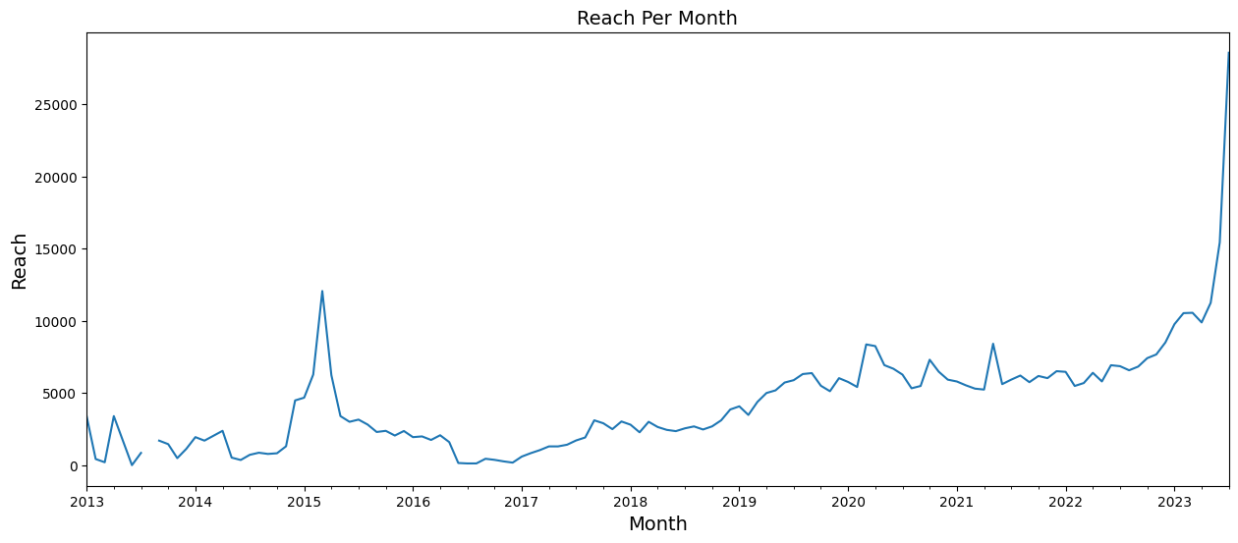

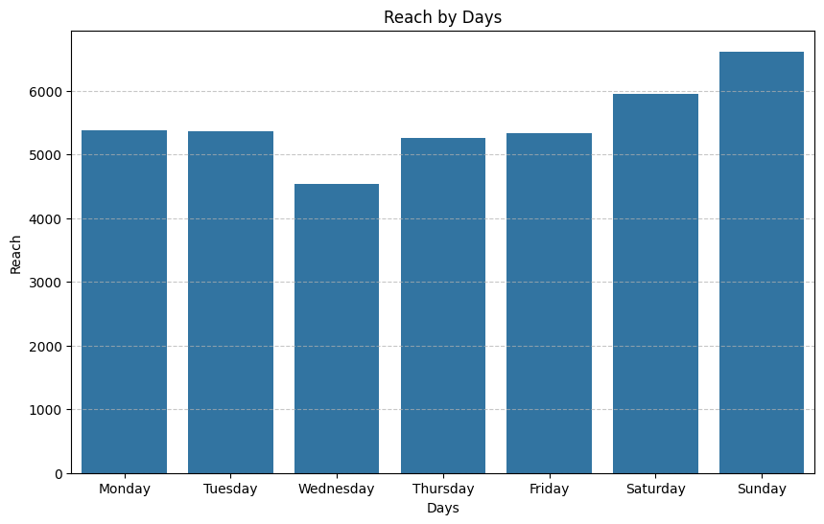

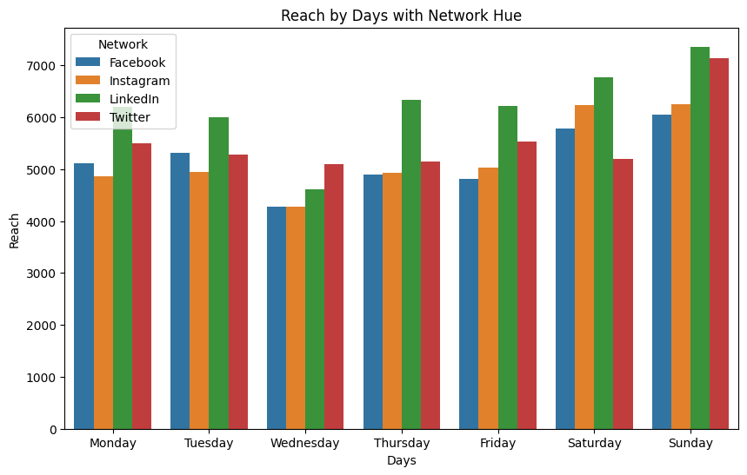

Reach follows the same pattern as impression

**Sent by Analysis**

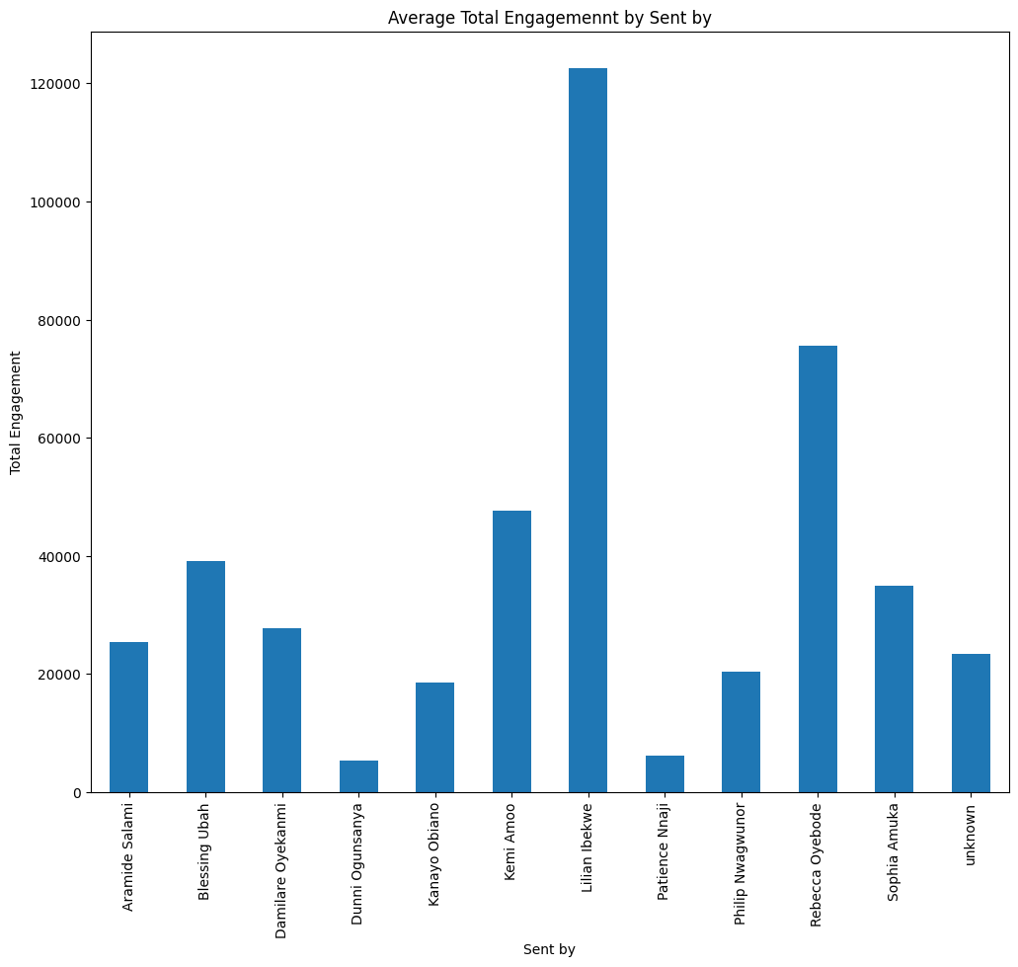

Lilian Ibekwe leads in engagement, amassing about 120,000 total engagements. Following closely, Rebecca Oyebode secures the second-highest total engagement with about 70,000. Kemi Amoo holds the third position with a total engagement of about 45,000, and Blessing Ubah follows as the fourth, accumulating about 38,500 total engagements. Sophia Amuka claims the fifth spot with about 35,000 engagements, while the subsequent rankings are as follows: Damilare Oyekanmi, Aramide Salami, Philip Nwagwunor, Kanayo Obiano, Patience Nnaji, and Dunni Ogunsanya.

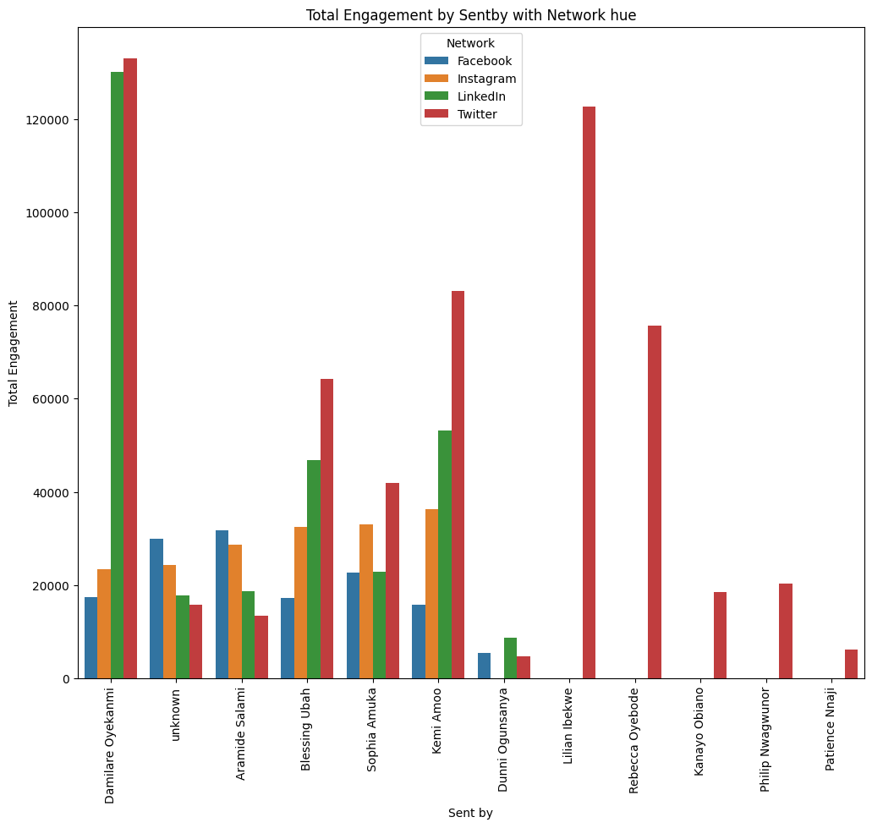

Damilare Oyekanmi dominates Twitter with the highest engagement, exceeding 120,000 total engagements, closely followed by LinkedIn, also surpassing 120,000. However, his engagement on Instagram and Facebook is comparatively lower, with 22,000 and below 20,000, respectively.

Aramide Salami takes the lead in Facebook engagement with about 30,000, followed by Instagram with approximately 28,000. LinkedIn and Twitter follow with both below 20,000 engagements.

Blessing Ubah commands Twitter with the highest total engagement, around 63,000, followed by LinkedIn with about 48,000 engagements. Instagram secures the third position with about 30,000 total engagements, while Facebook trails with below 20,000 total engagements. Sophia Amuka tops Twitter with the highest total engagement, about 42,000, followed by Instagram with approximately 33,000. She maintains the same engagement level on Facebook and LinkedIn, both totaling about 22,000.

Kemi Amoo claims the highest total engagement on Twitter, reaching about 80,000. LinkedIn follows with about 50,000 total engagements, while Instagram secures the third position with about 38,000. Facebook lags behind with below 20,000 total engagements.

Dunni Ogunsanya records total engagements below 20,000 across LinkedIn, Facebook, and Twitter, ranking first, second, and third, respectively.

Lilian Ibekwe exclusively engages on Twitter, accumulating a total engagement of about 120,000.

Rebecca Oyebode's engagements are solely on Twitter, totaling about 78,000.

Kanayo Obiano's engagements are confined to Twitter, with a modest figure just below 20,000.

Philip Nwagwunor's engagements are concentrated on Twitter, totaling about 20,000.

Patience Nnaji's engagements are confined to Twitter, totaling below 20,000.

**Post Word Cloud**

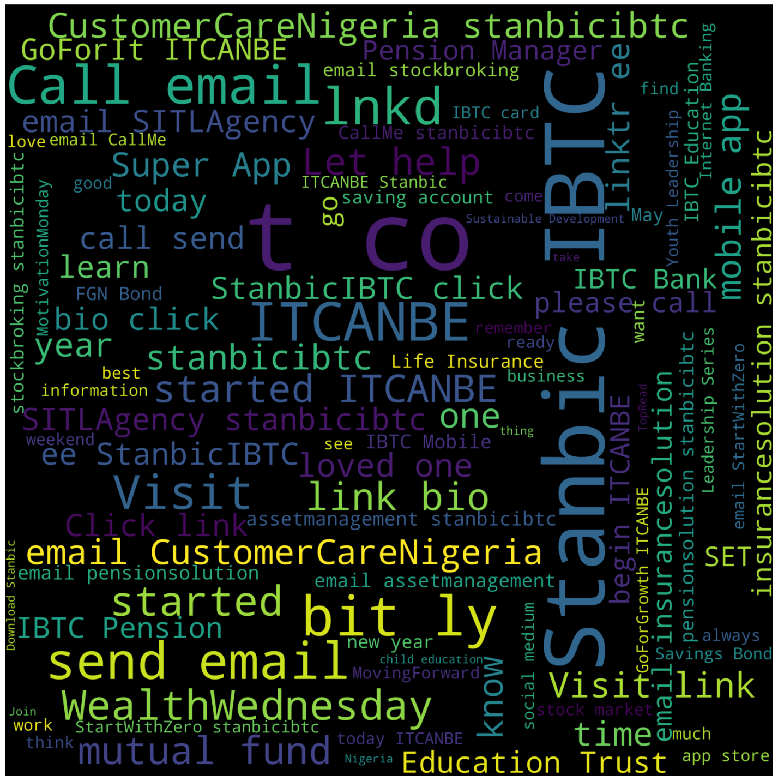

## Linkdin Post Word Cloud

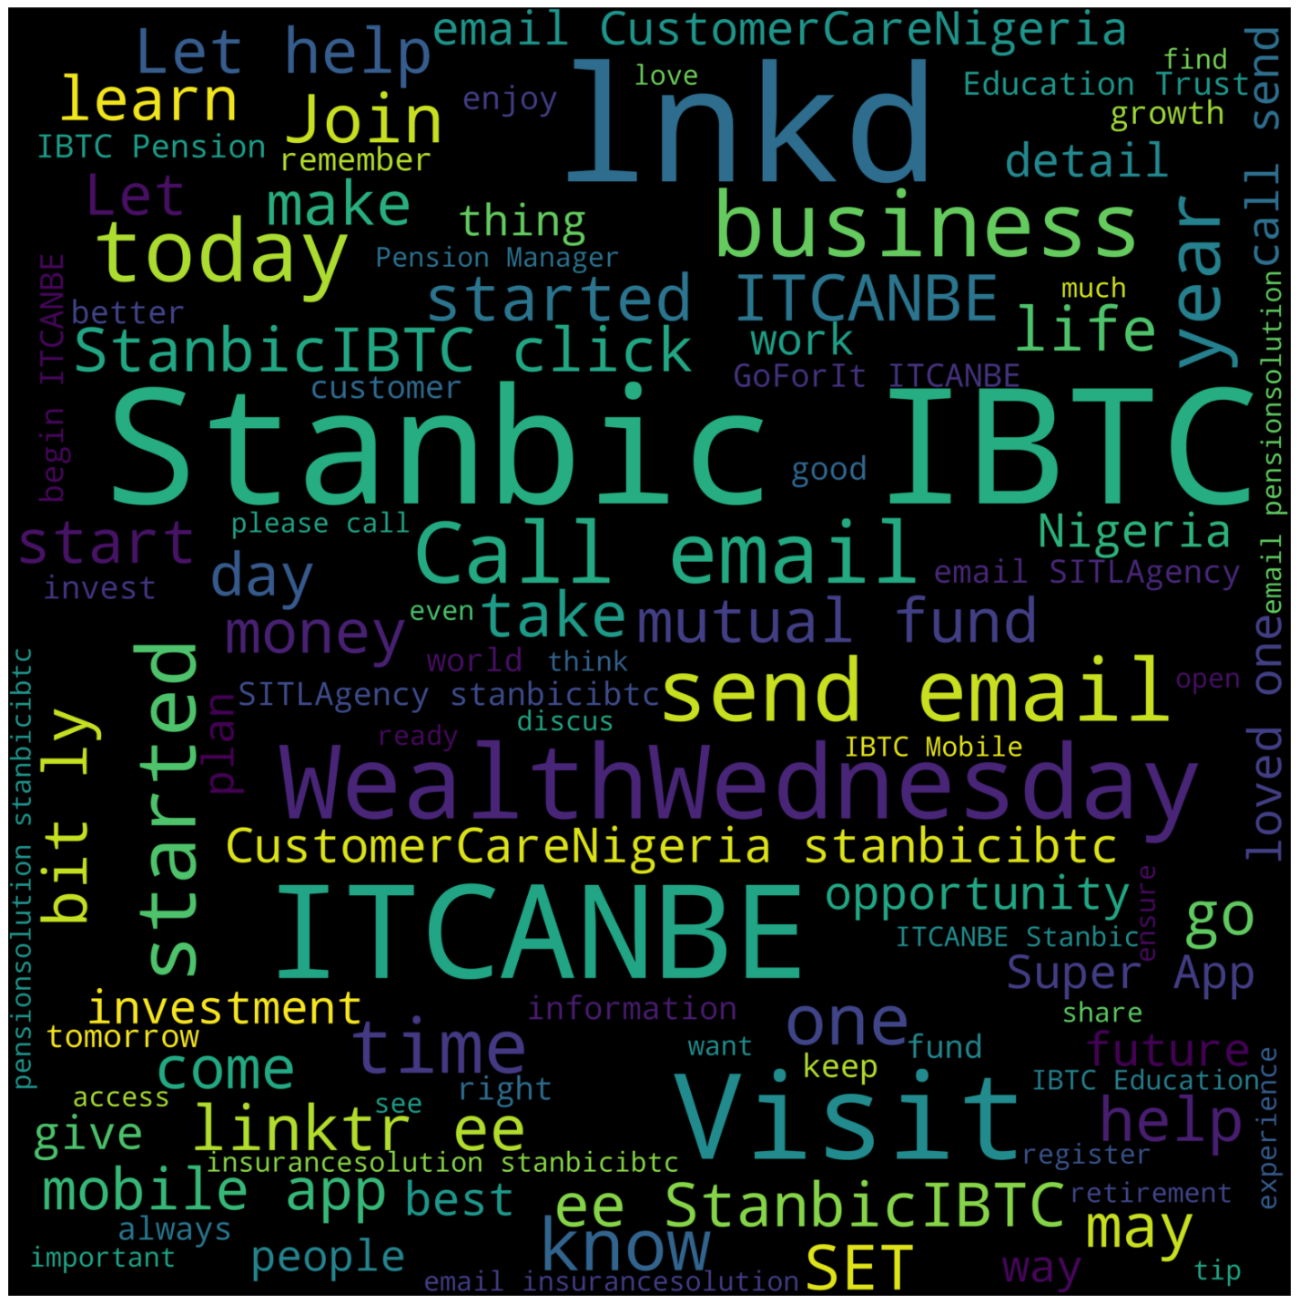

## Twitter Post Word Cloud

## C:\Users\Administrator\AppData\Local\Microsoft\Windows\INetCache\Content.MSO\34CEF64B.tmp

## Facebook Post Word Cloud

## C:\Users\Administrator\AppData\Local\Microsoft\Windows\INetCache\Content.MSO\DAA4F191.tmp

## Instagram Post Word Cloud

## C:\Users\Administrator\AppData\Local\Microsoft\Windows\INetCache\Content.MSO\BA8A776D.tmp

## Tag Word Cloud

## C:\Users\Administrator\AppData\Local\Microsoft\Windows\INetCache\Content.MSO\D3456903.tmp

**Recommendations:**

**1. Content Strategy Optimization:** Focus on creating more poll content, as it consistently emerges as the most engaging type. Additionally, consider incorporating document content on LinkedIn for in-depth information. Visual and interactive content, such as videos and carousels, should be prioritized, while text-based and link content may benefit from more engaging formats.

**2. Platform-Specific Strategies:** Recognize the dominance of LinkedIn in engagement and tailor content strategies accordingly. Consider the professional nature of LinkedIn's audience and the preference for polls and documents. Adapt content for Twitter's Monday engagement peaks and Instagram's visual appeal. Facebook may require a balance between professional and casual content.

**3. Day and Time Optimization:** Leverage the insights on days and hours of engagement to schedule posts strategically. Aim for higher activity periods on Sundays, Mondays, and Thursdays, particularly during the peak engagement hours at 7 AM, 2 PM, and 5 PM.

**4. Yearly and Weekly Engagement Trends:** Acknowledge the dynamic nature of engagement throughout the year. Identify and capitalize on peaks during specific quarters. Focus on refining strategies for Sundays, the day with consistently high engagement.

**5. Click-Through Rate (CTR) Enhancement:** Explore the patterns in CTR across days and platforms to refine content strategies. Prioritize Wednesdays for potentially higher CTR. Tailor content for specific platforms on different days based on observed CTR variations.

**6. Impression and Reach Optimization:** Understand the evolution of impressions and reach over time and adjust strategies accordingly. Focus on the impact of content on Sundays and tailor content to each platform's dynamics for optimized impressions.

**7. Influencer Engagement**: Recognize the influence of individuals like Lilian Ibekwe and Rebecca Oyebode. Collaborate with them for content promotion, and consider their engagement patterns on different platforms for targeted campaigns.

**8. Consistent Monitoring:** Regularly analyze engagement metrics, adapt strategies based on real-time data, and remain responsive to changing user behaviors and platform dynamics.

**Summarization:**

The report provides valuable insights into content engagement across different types, social media platforms, days, and hours. Poll content stands out as the most engaging, particularly on LinkedIn, emphasizing the importance of interactive formats. LinkedIn dominates in engagement, suggesting a professional-focused audience, while engagement patterns vary on Twitter, Instagram, and Facebook.

Days and hours exhibit distinct engagement trends, with Sundays being the most active day and specific peak hours at 7 AM, 2 PM, and 5 PM. Yearly and weekly trends highlight the importance of strategic planning for peak periods and Sundays. Click-through rates vary across days and platforms, emphasizing the need for tailored content strategies. Impressions and reach show evolving engagement dynamics, with Sundays having the highest impact.

Individual influencers play a significant role, with Lilian Ibekwe and Rebecca Oyebode leading in engagement. Tailoring content based on their preferences and collaborating for promotions can enhance overall engagement. Overall, the report underscores the need for adaptive content strategies aligned with user behaviors and platform-specific dynamics for optimal engagement.